ROSSMOYNE SENIOR HIGH SCHOOL

Semester Two Examination, 2010

Question/Answer Booklet

MATHEMATICS 3A/3B

Section One:

Calculator-free

Your name

Your Teacher (Circle one)
Belonogoff Benko Bestall Jones
Robinso n Sutton Tay

Time allowed for this section
Reading time before commencing work: 5 minutes
Working time for paper: 50 minutes

Material required/recommended for this section

To be provided by the supervisor
This Question/Answer booklet
Formula sheet

To be provided by the candidate
Standard items: pens, pencils, pencil sharpener, eraser, correction fluid, ruler, highlighters

Special items: nil

Important note to candidates

No other items may be used in this section of the examination. It is your responsibility to ensure that you do not have any unauthorised notes or other items of a non-personal nature in the examination room. If you have any unauthorised material with you, hand it to the supervisor before reading any further.

Structure of this paper

Section | Number of questions available | Number of questions to be answered | Working time (minutes) | Marks available
Section One:  Calculator-free | 7 | 7 | 50 | 40
Section Two:  Calculator-assumed | 12 | 12 | 100 | 80
 |  |  |  | 120

Instructions to candidates

- The rules for the conduct of Western Australian external examinations are detailed in the Year 12 Information Handbook 2010. Sitting this examination implies that you agree to abide by these rules.

- Write your answers in the spaces provided in this Question/Answer Booklet. Spare pages are included at the end of this booklet. They can be used for planning your responses and/or as additional space if required to continue an answer.
- Planning: If you use the spare pages for planning, indicate this clearly at the top of the page.
- Continuing an answer: If you need to use the space to continue an answer, indicate in the original answer space where the answer is continued, i.e. give the page number. Fill in the number of the question(s) that you are continuing to answer at the top of the page.

- Show all your working clearly. Your working should be in sufficient detail to allow your answers to be checked readily and for marks to be awarded for reasoning. Incorrect answers given without supporting reasoning cannot be allocated any marks. For any question or part question worth more than two marks, valid working or justification is required to receive full marks. If you repeat an answer to any question, ensure that you cancel the answer you do not wish to have marked.

- It is recommended that you do not use pencil except in diagrams.

Section One: Calculator-free (40 Marks)
This section has seven (7) questions. Answer all questions. Write your answers in the space provided.

Working time for this section is 50 minutes.

Question 1 (5 marks)
The number of telephone calls answered per hour in an office over a survey period of 22 hours is shown in the table below.

Number of calls | 0 | 1 | 2 | 3 | 4 | 5 | 6
Frequency | 1 | 4 | 6 | 5 | 3 | 1 | 2

(a) Construct a median boxplot for this data. (3 marks)
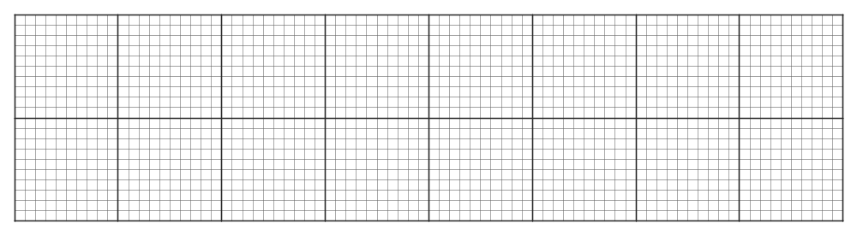

(b) Use the boxplot to explain whether the mean number of telephone calls answered per hour would be higher than, lower than or the same as, the median. (2 marks)

Question 2 (6 marks)
(a) Expand and simplify with positive indices: - 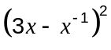. (2 marks)

(b) The curve 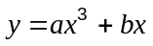 has a stationary point at (1, -4).
Find the values of and . (4 marks)

Question 3 (5 marks)
A universal set 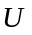has two subsets, 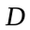 and 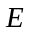such that 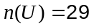, 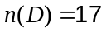, 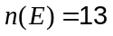 and 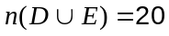.

(a) Show this information using a Venn diagram. (2 marks)

(b) Calculate

(i) 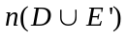 (1 mark)

(ii) 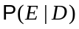 (1 mark)

(c) 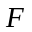 is a third subset of and is such that 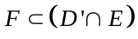. State all possible values for 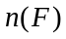.
(1 mark)

Question 4 (7 marks)
The diagram shows the graph of 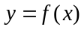.
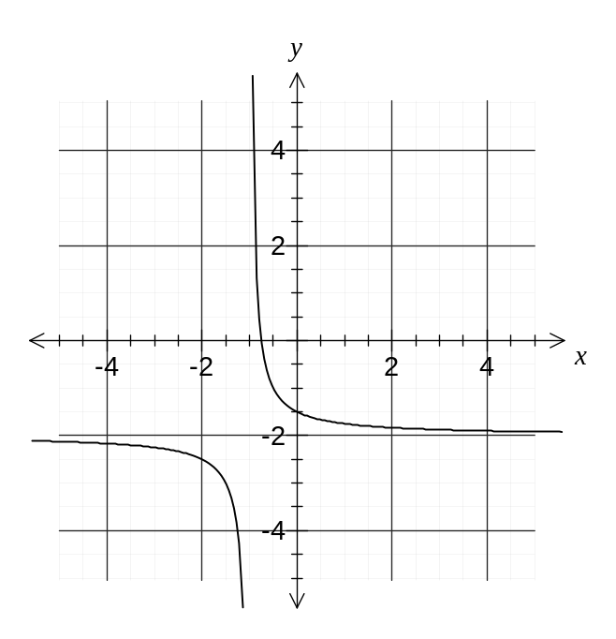
(a) State the equation(s) of the asymptote(s) for the graph of . (1 mark)

(b) For what values of does the graph appear to be concave up? (1 mark)

(c) How many lines of symmetry does the graph of have? (1 mark)

(d) Draw the tangent to the graph of when 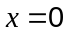 and hence estimate the value of 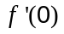. (2 marks)

(e) State the domain and range of . (2 marks)

Question 5 (8 marks)
(a) Five different books are piled randomly on top of each other on a table. If the authors of the books are Keats, Byron, Adams, Pope and Thomas determine the probability that

(i) the book by Pope is at the bottom of the pile. (1 mark)

(ii) the books by Keats and Byron are together at the top of the pile. (1 mark)

(iii) the books by Thomas and Adams are not together. (2 marks)

(b) The lengths of a brand of wooden posts follow a normal distribution with a mean of 179cm and a standard deviation of 4cm. Determine the probability that a randomly chosen post is longer than 175cm given that it is less than 183cm. (4 marks)

Question 6 (5 marks)
(a) A curve has equation 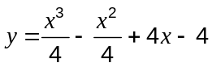. Find the equation of the tangent to this curve at the point (2, 5). (3 marks)

(b) If 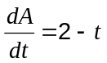 and when 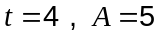, find an expression for in terms of . (2 marks)

Question 7 (4 marks)
The graph shows the function 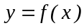.
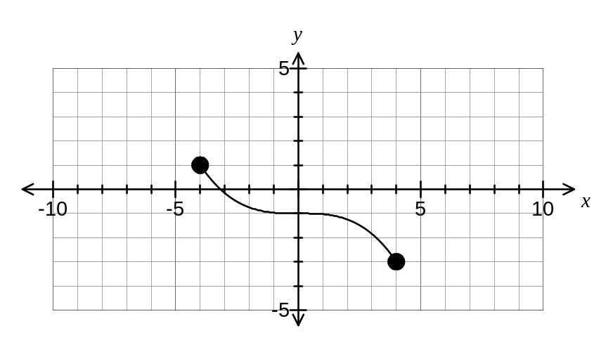

(a) The graph below shows the function 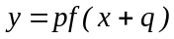. State the values of p and q. (2 marks)
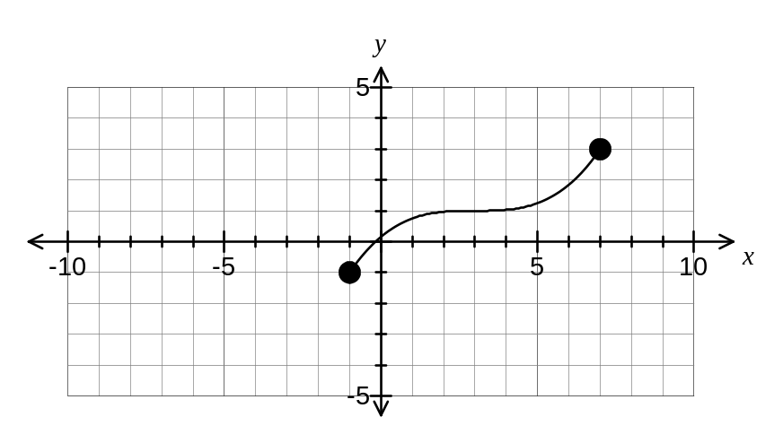

(b) On the axes below sketch the graph of 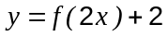. (2 marks)
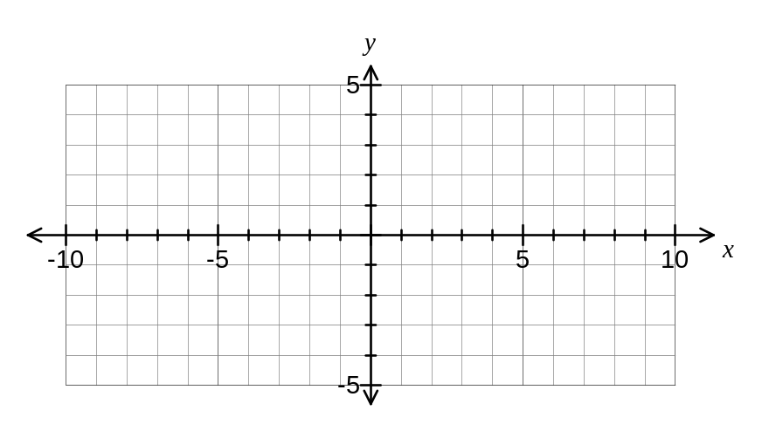

Additional working space

Question number(s):

Additional working space

Question number(s):

